Project Title: Smart Fashion Recommender Application Project Design Phase-I - Solution Fit Template

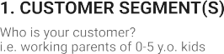

Online shopping is user friendly and the savings is extravagant

pros: Easy to access

cons: Delay in delivery

Budget and network

The Customers are Adults from all the genders of age between 15 – 55

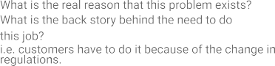

No sufficient manpower and distant location

Order the cloths prior to the expected date

Delay in delivery time

|  |  |  |  |  |
| --- | --- | --- | --- | --- |
|  | **3. TRIGGERS TR**  What triggers customers to act? i.e. seeing their neighbour installingsolar panels, reading about a more efﬁcient solution in the news.  Seeing neighbor Dressing Styles and  Availability of the product | **10. YOUR SOLUTION SL**  If you are working on an existing business, write down your current solution ﬁrst,ﬁll in the canvas, and check how much it ﬁts reality.  If you are working on a new business proposition, then keep it blank until you ﬁll inthe canvas and come up with a solution that ﬁts within customer limitations, solves a problem and matches customer behaviour. | 1. **CHANNELS of BEHAVIOUR CH**    1. **ONLINE**   What kind of actions do customers take online? Extract online channels from #7   * 1. **OFFLINE**   What kind of actions do customers take ofﬂine? Extract ofﬂine channels from #7and use them for customer development. |  |
| **4. EMOTIONS: BEFORE / AFTER EM**  How do customers feel when they face a problem or a job and afterwards?  i.e. lost, insecure > conﬁdent, in control - use it in your communication strategy & design.  Felling Sad and Frustration > Selfconfident | Make a ChatBot Assistant for shopping and send notifications when new collections have arrived | ONLINE: Customers buy the new clothes  OFFLINE: Customers will use the clothes |